**AWS, MySQL and DynamoDB**

Task1

Firstly I found mentors created RDS database ‘dilab-mysql’ and copy endpoint and port

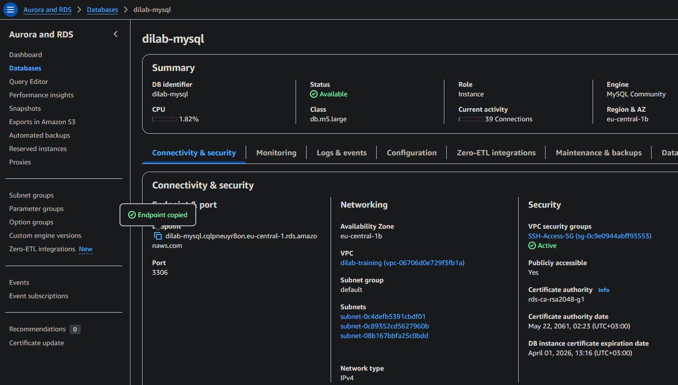

Found my EC2 Public DNS

Then created connection to RDS via EC2 Linux2023. 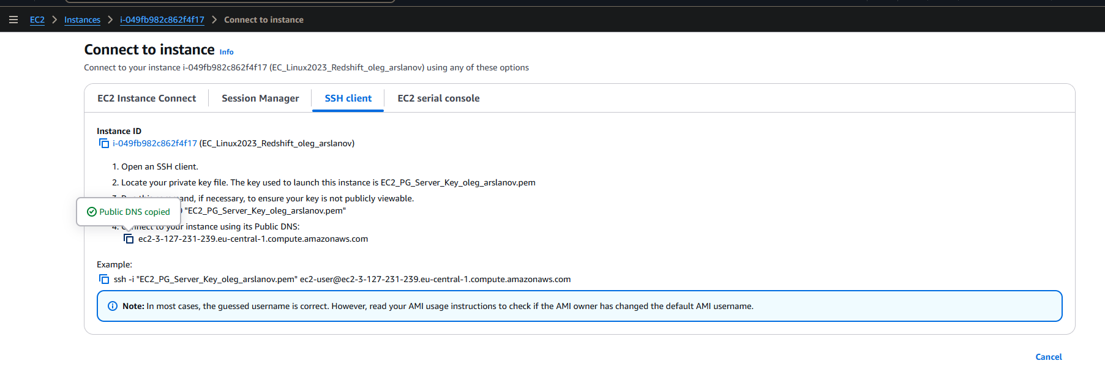

Connect to VPN. I made PUTTY conection from EC2 to RDS

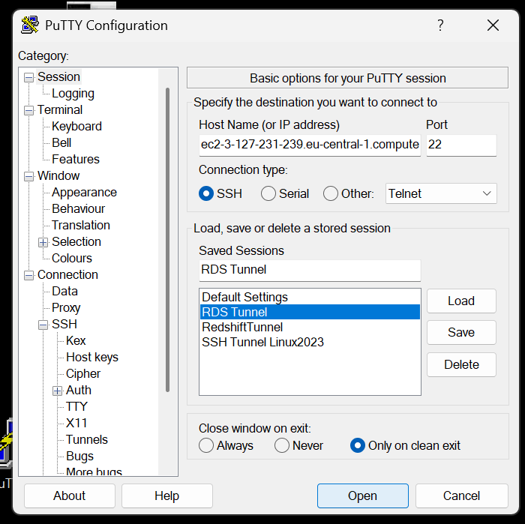

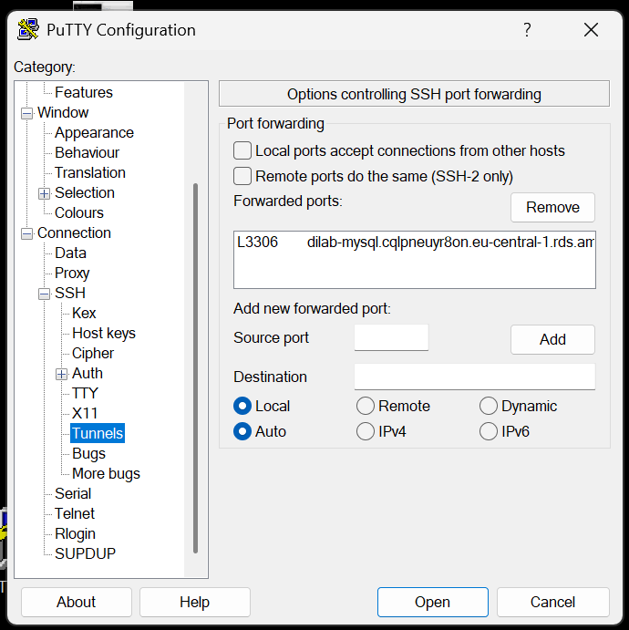

When I added connection I open DBeaver and made connection to RDS via PUTTY

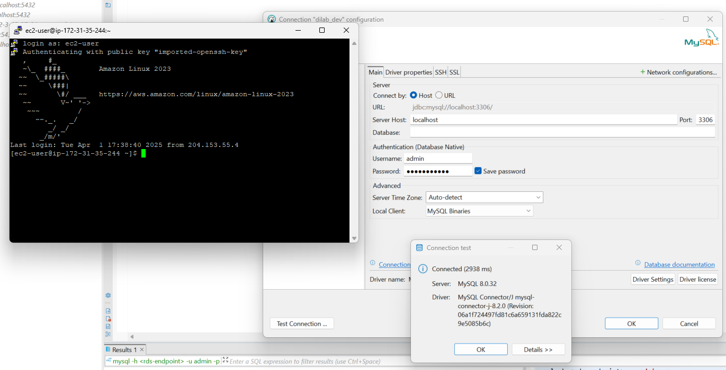

Connect to RDS DB like admin

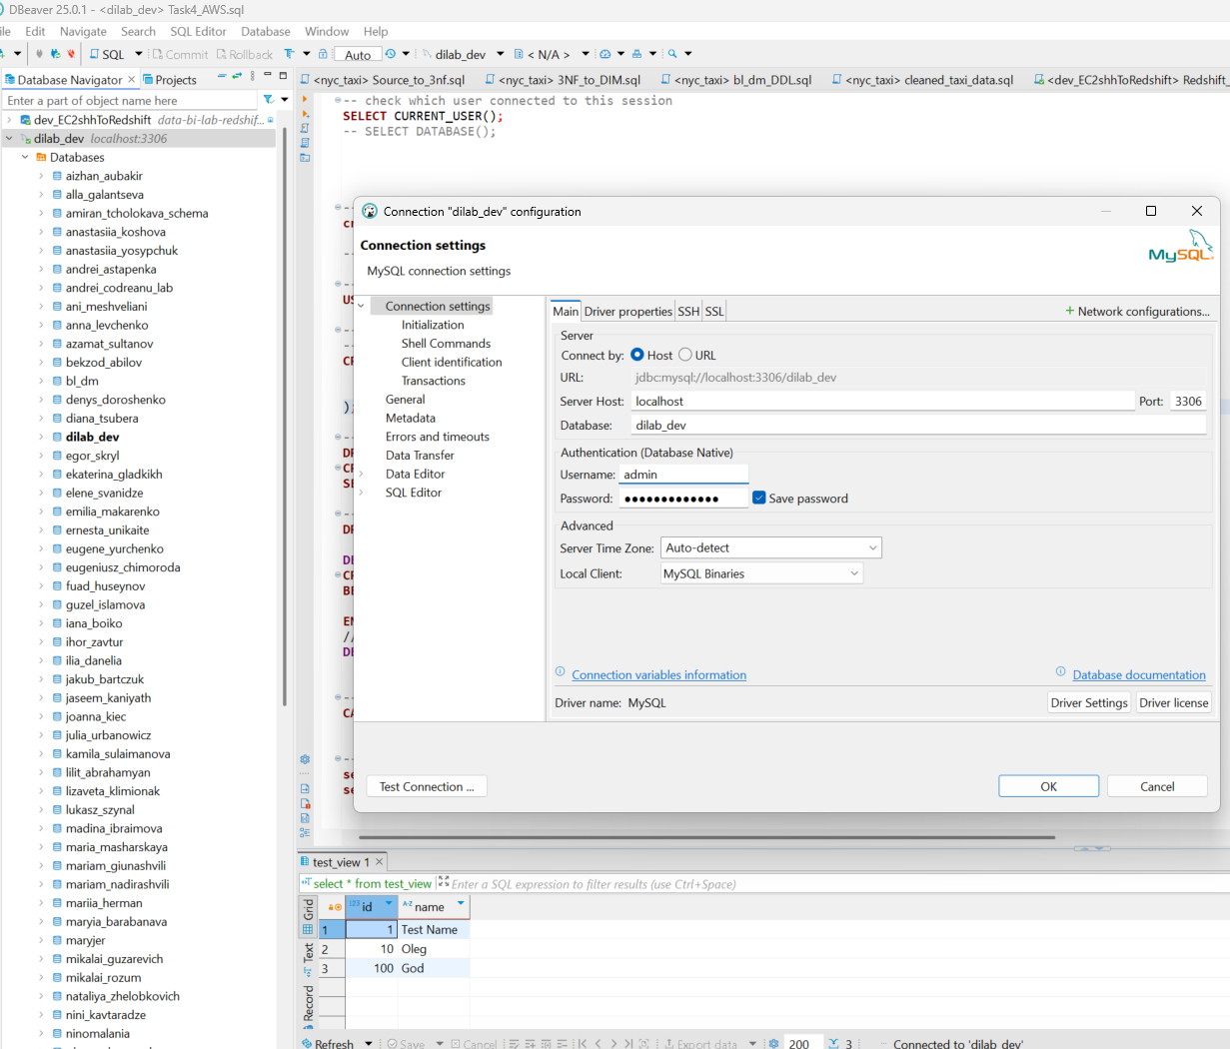

Connect to DB with user: oleg_arslanov with all privileges, but only on schemas: dilab_dev and oleg_arslanov_schema

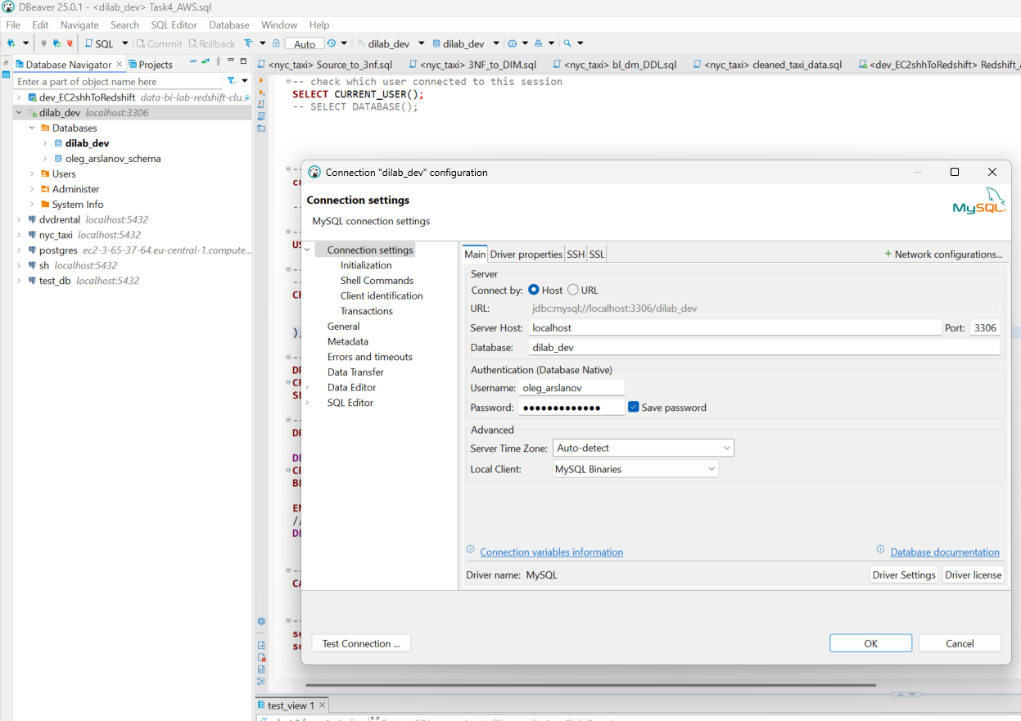

Created: simple table, view and procedure

**Task 2**

So I open in Aurora console Aurora and RDS and open Query editor. 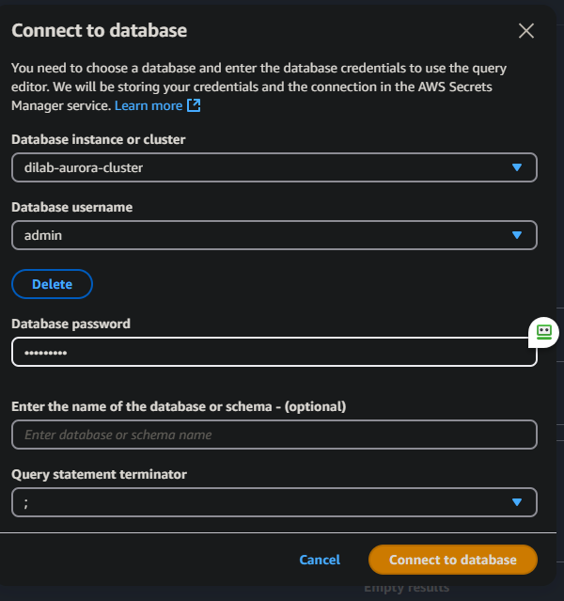

Data Api is needed

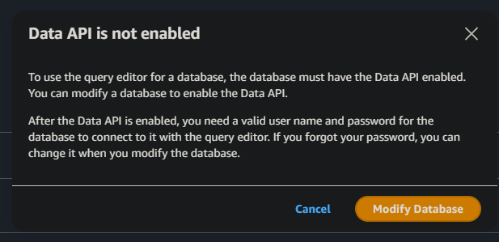

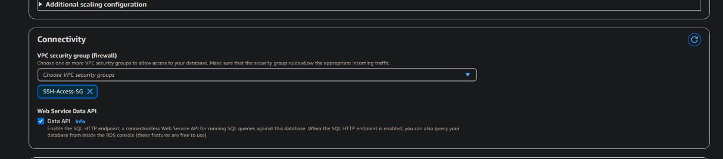

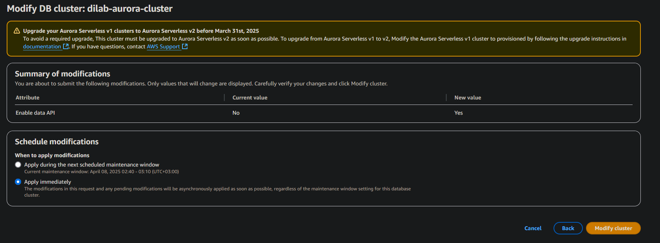

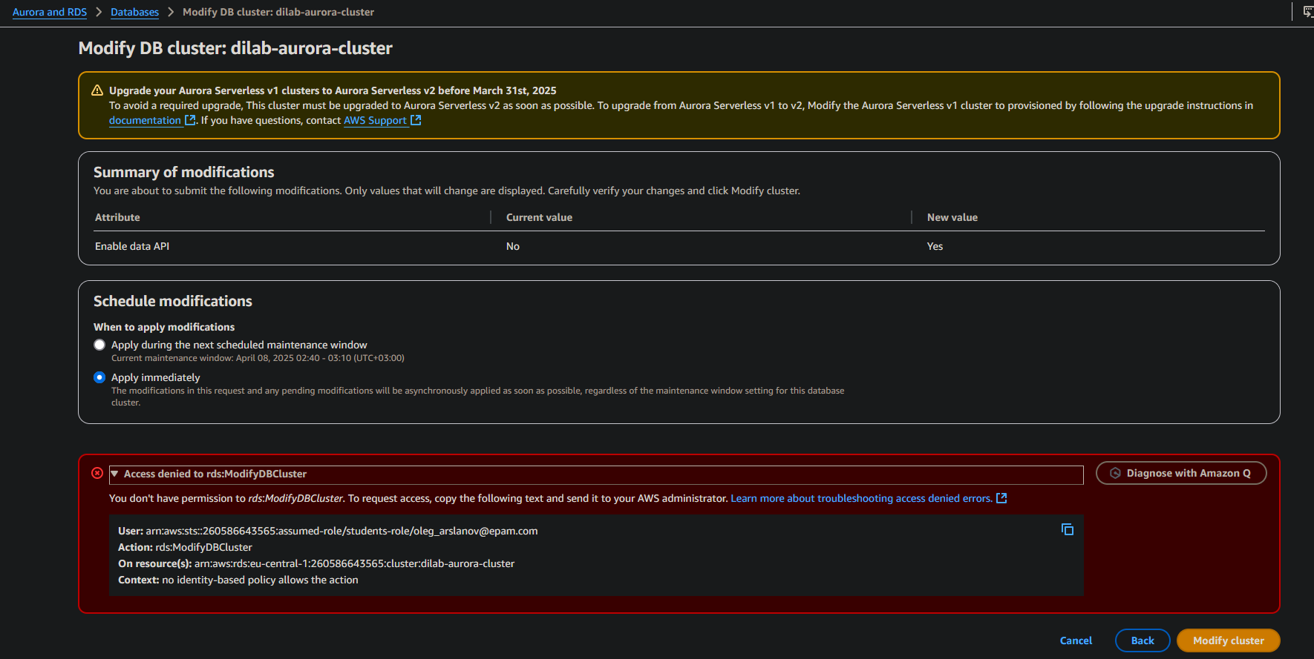

No I have not rights to do that … Mentor wrote that we can skip this task

So I probe made optional task

First I found my IP

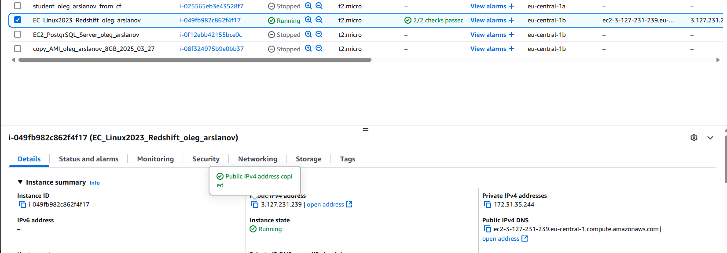

Then I made connection in DBeaver

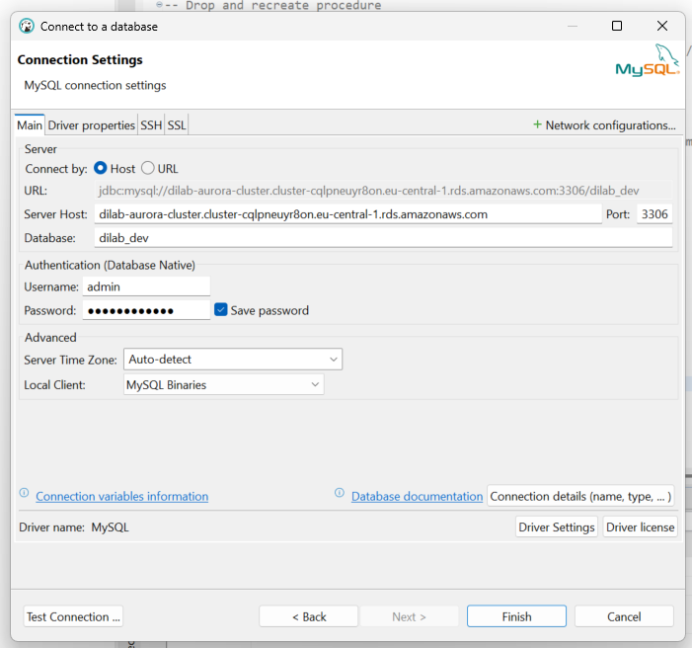

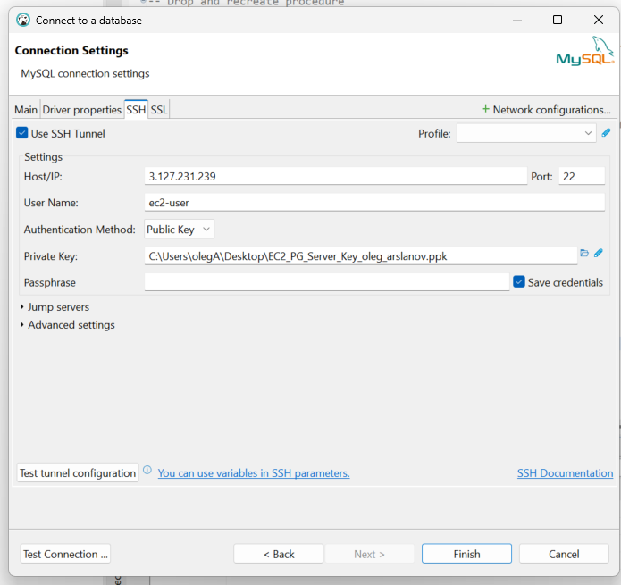

Test connection tunnel

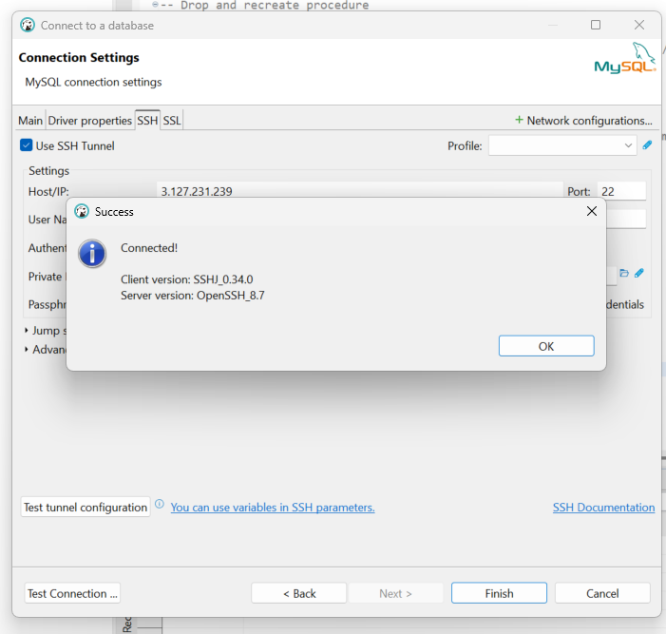

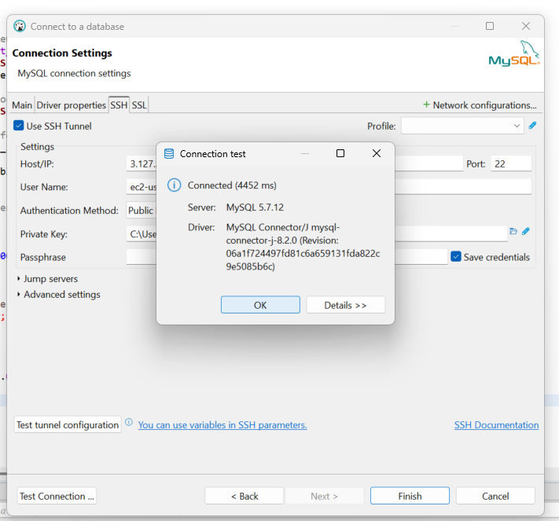

But something wrong : Communications link failure

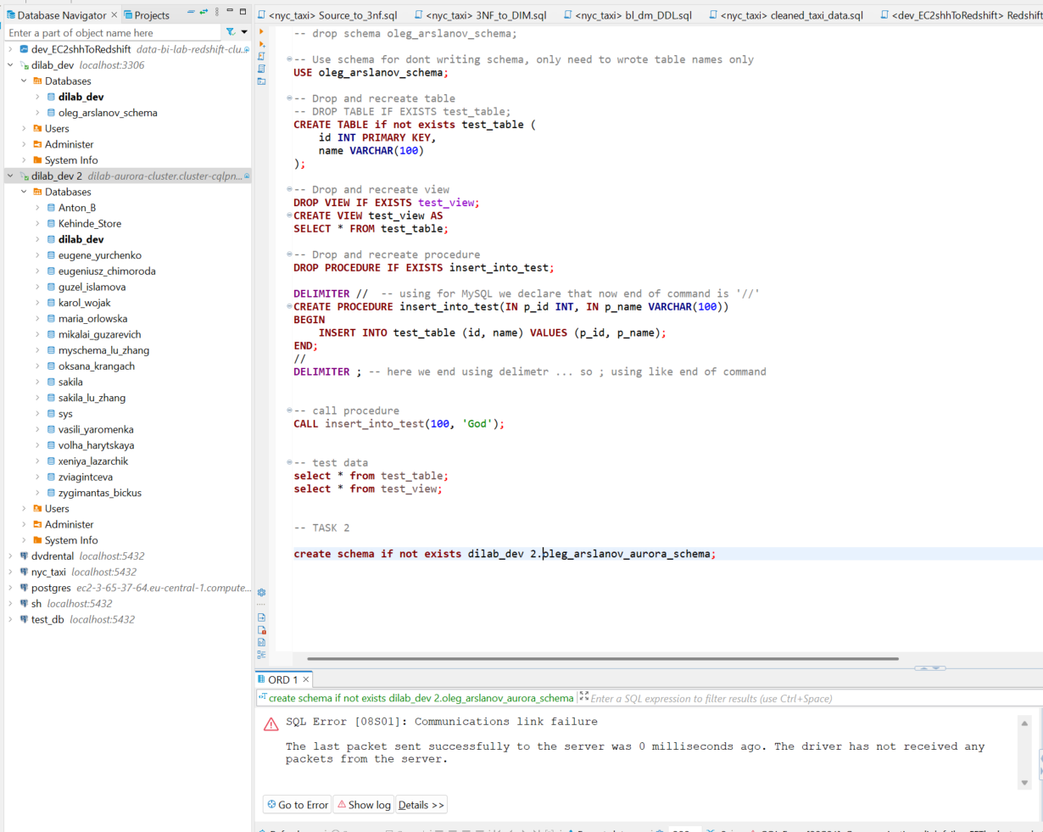

So I leave this task … when it will be ready we can continue 😊

**Task 3 DynamoDB**

Added table AWS console -> DynamoDB. Hit Create table. Added Table name, Partition key and hit Create table

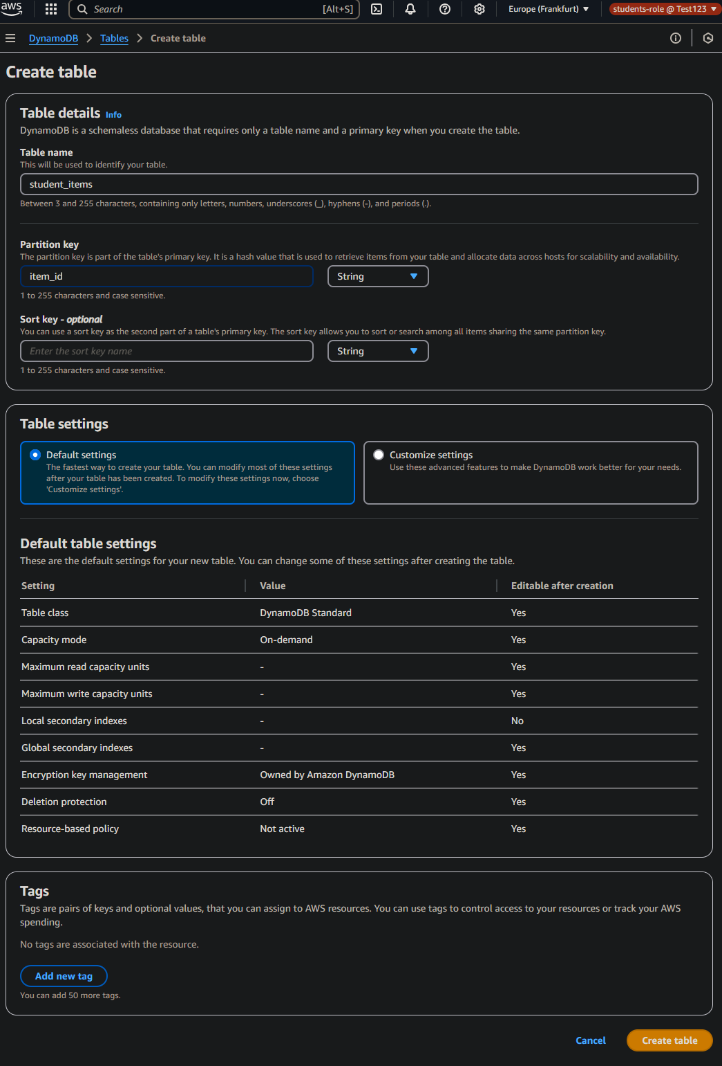

Then choose Explore items -> create item and insert rows 😊

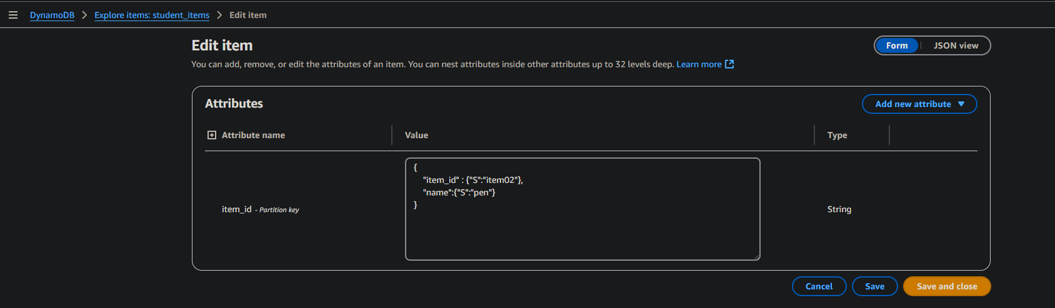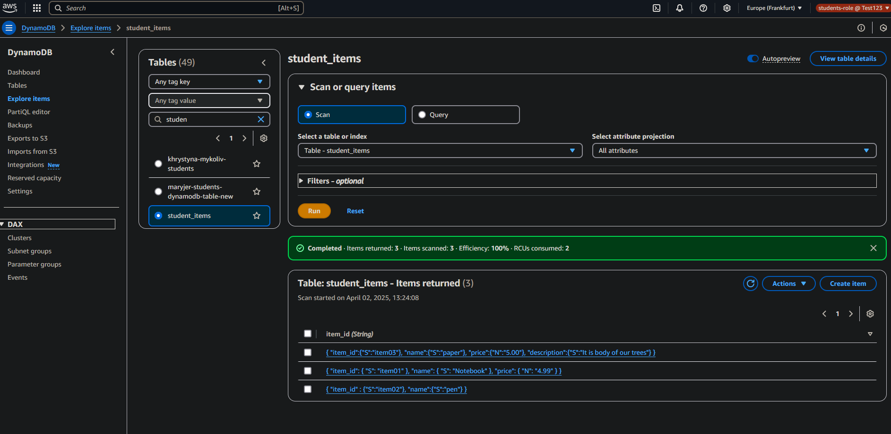

Added to table rows



Here we use only CLI (not console)

I open CMD and check have we instaled AWS CLI …yes it installed

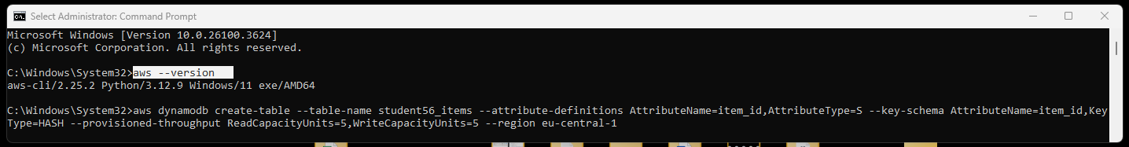

Then looking for list of profiles … and create table... AWS DynamoDB return all detailed info about created table

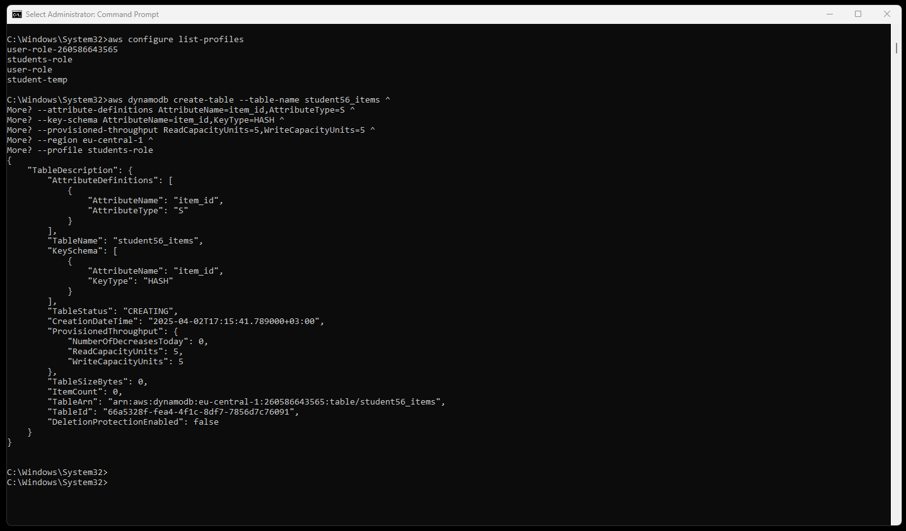

I choose item_id as partition key because:

* it is unique indetifier
* enables fast CRUD operations by ID
* most queries will filter by item_id, avoiding costly Scan operations

Now I created JSON format file to add 20 rows by one time to our table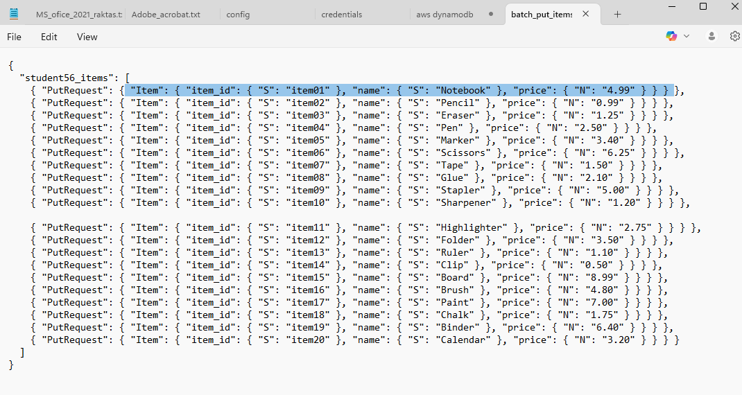

Now we made command to create table from file

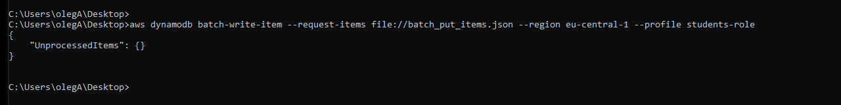

So we made 20 rows from one command

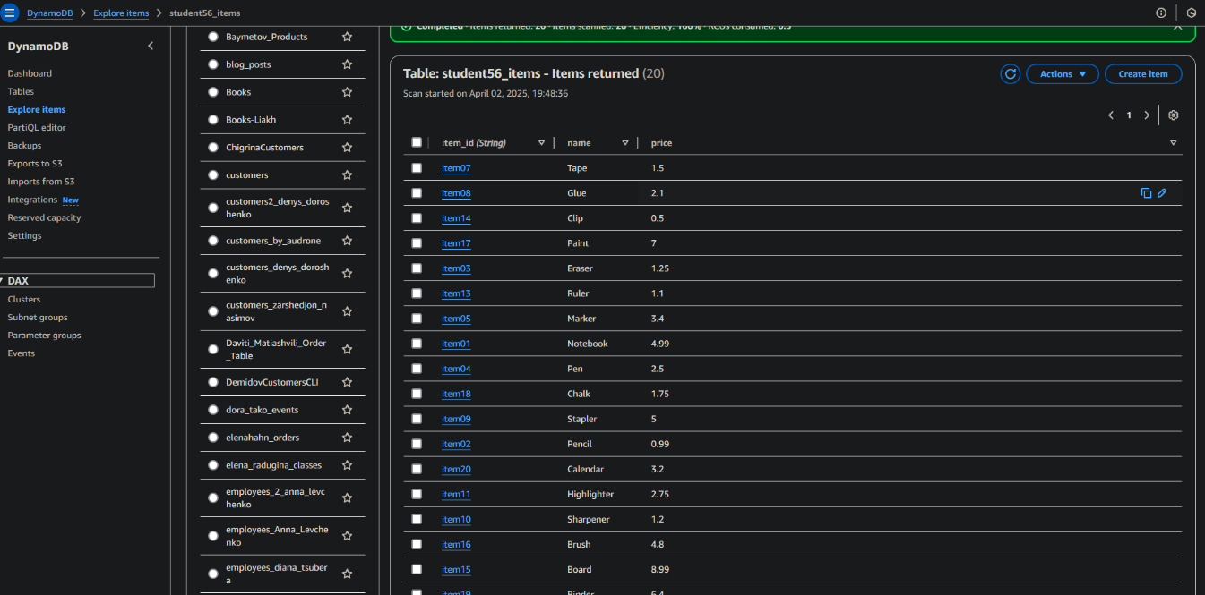

Next I made file with 5 retrieve rows

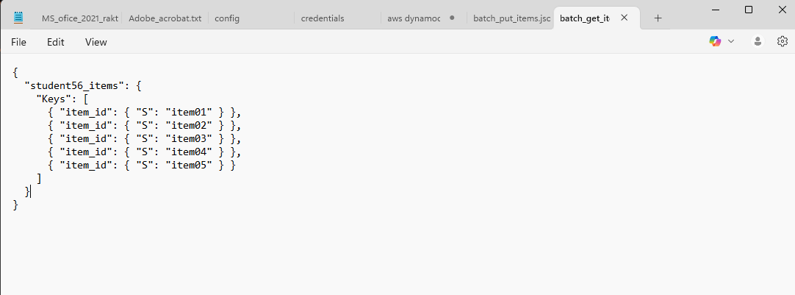

Next I use in CMD with AWS dynamodb command and retrieve 5 rows

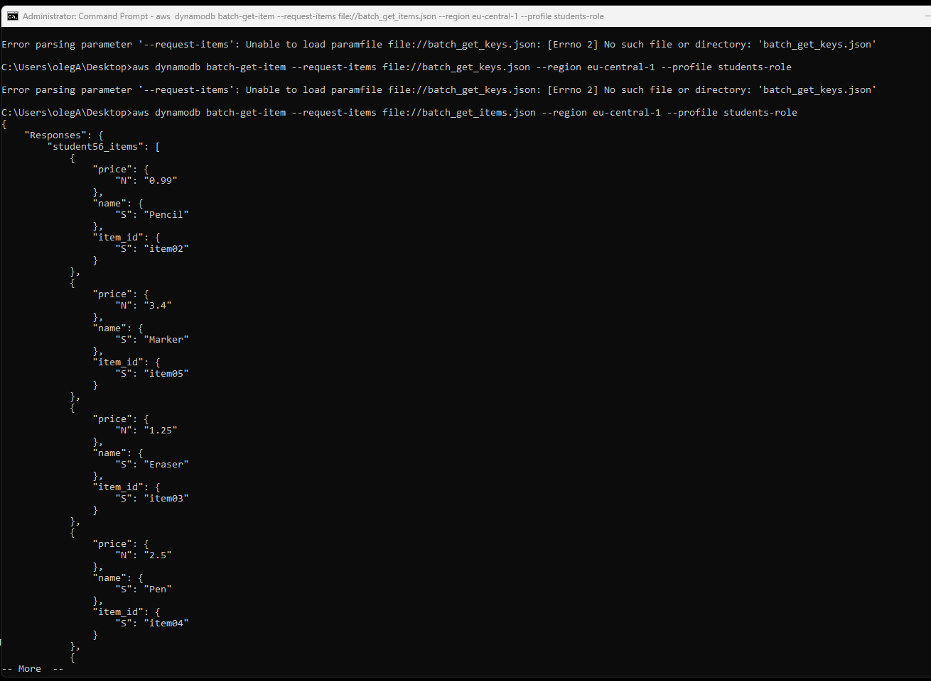

Make several selects using PartiQL syntax

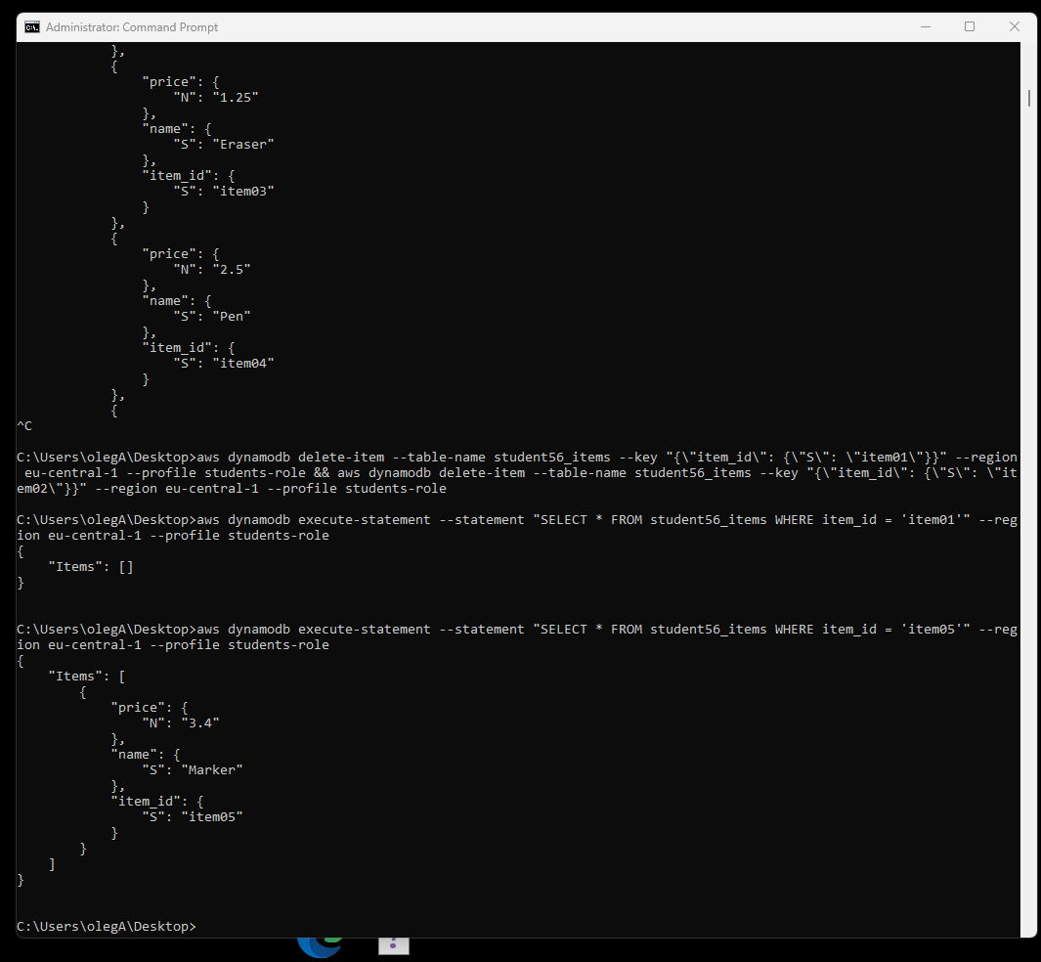

When I want to remove two rows from DynamoDB

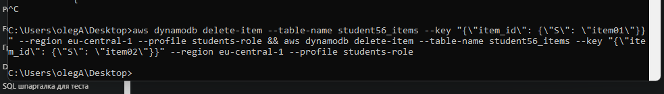

Yes there is delete two rows

